1) Select one UDP packet from your trace. From this packet, determine how many fields there are in the UDP header. (You shouldn’t look in the textbook! Answer these questions directly from what you observe in the packet trace.) Name these fields.

Answer:

UPD header consists of 4 fields and they are mentioned below which are observed from the trace generated through Wireshark application.

Source port, Destination port, Length, Checksum.

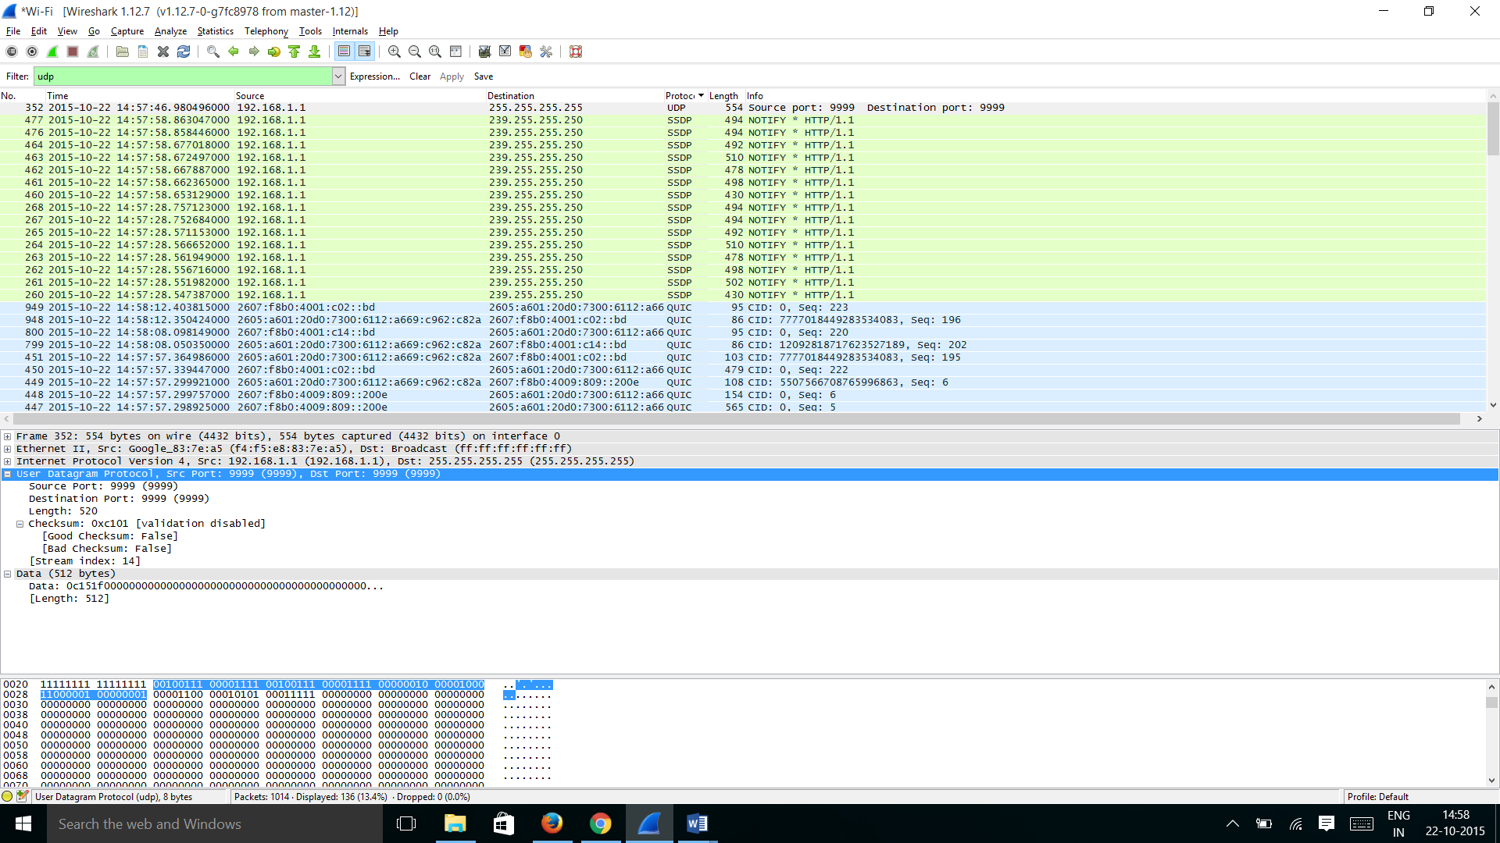

2) By consulting the displayed information in Wireshark’s packet content field for this packet, determine the length (in bytes) of each of the UDP header fields.

Answer:

UDP header has four fields each of length 2 bytes and hence the UDP header length is 8 bytes. Please find the screenshots attached for each field length.

Source Port = 2 bytes

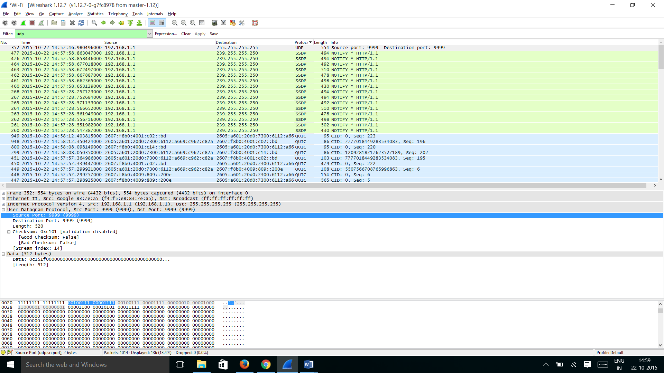

Destination port = 2 bytes

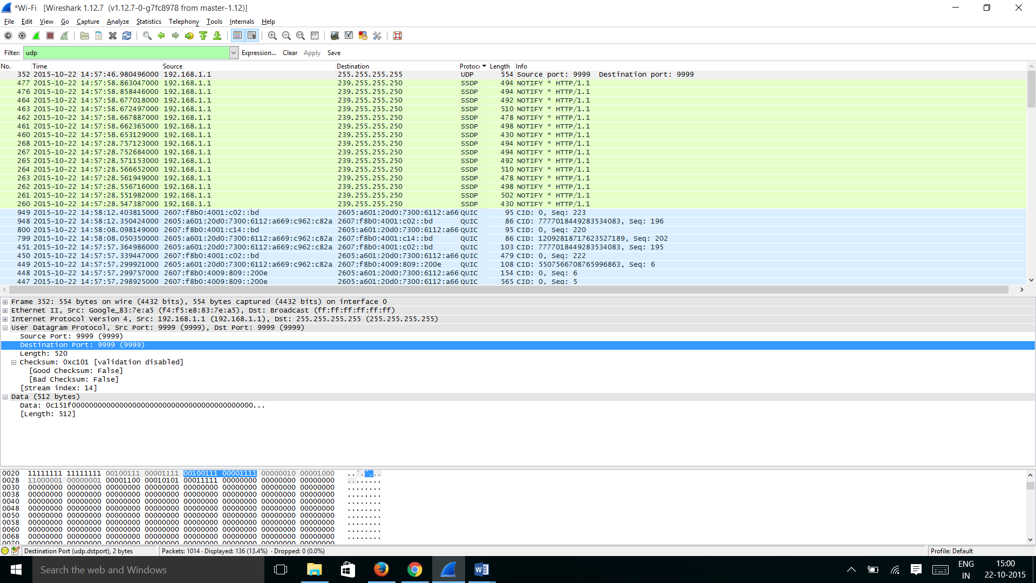

Length = 2 bytes

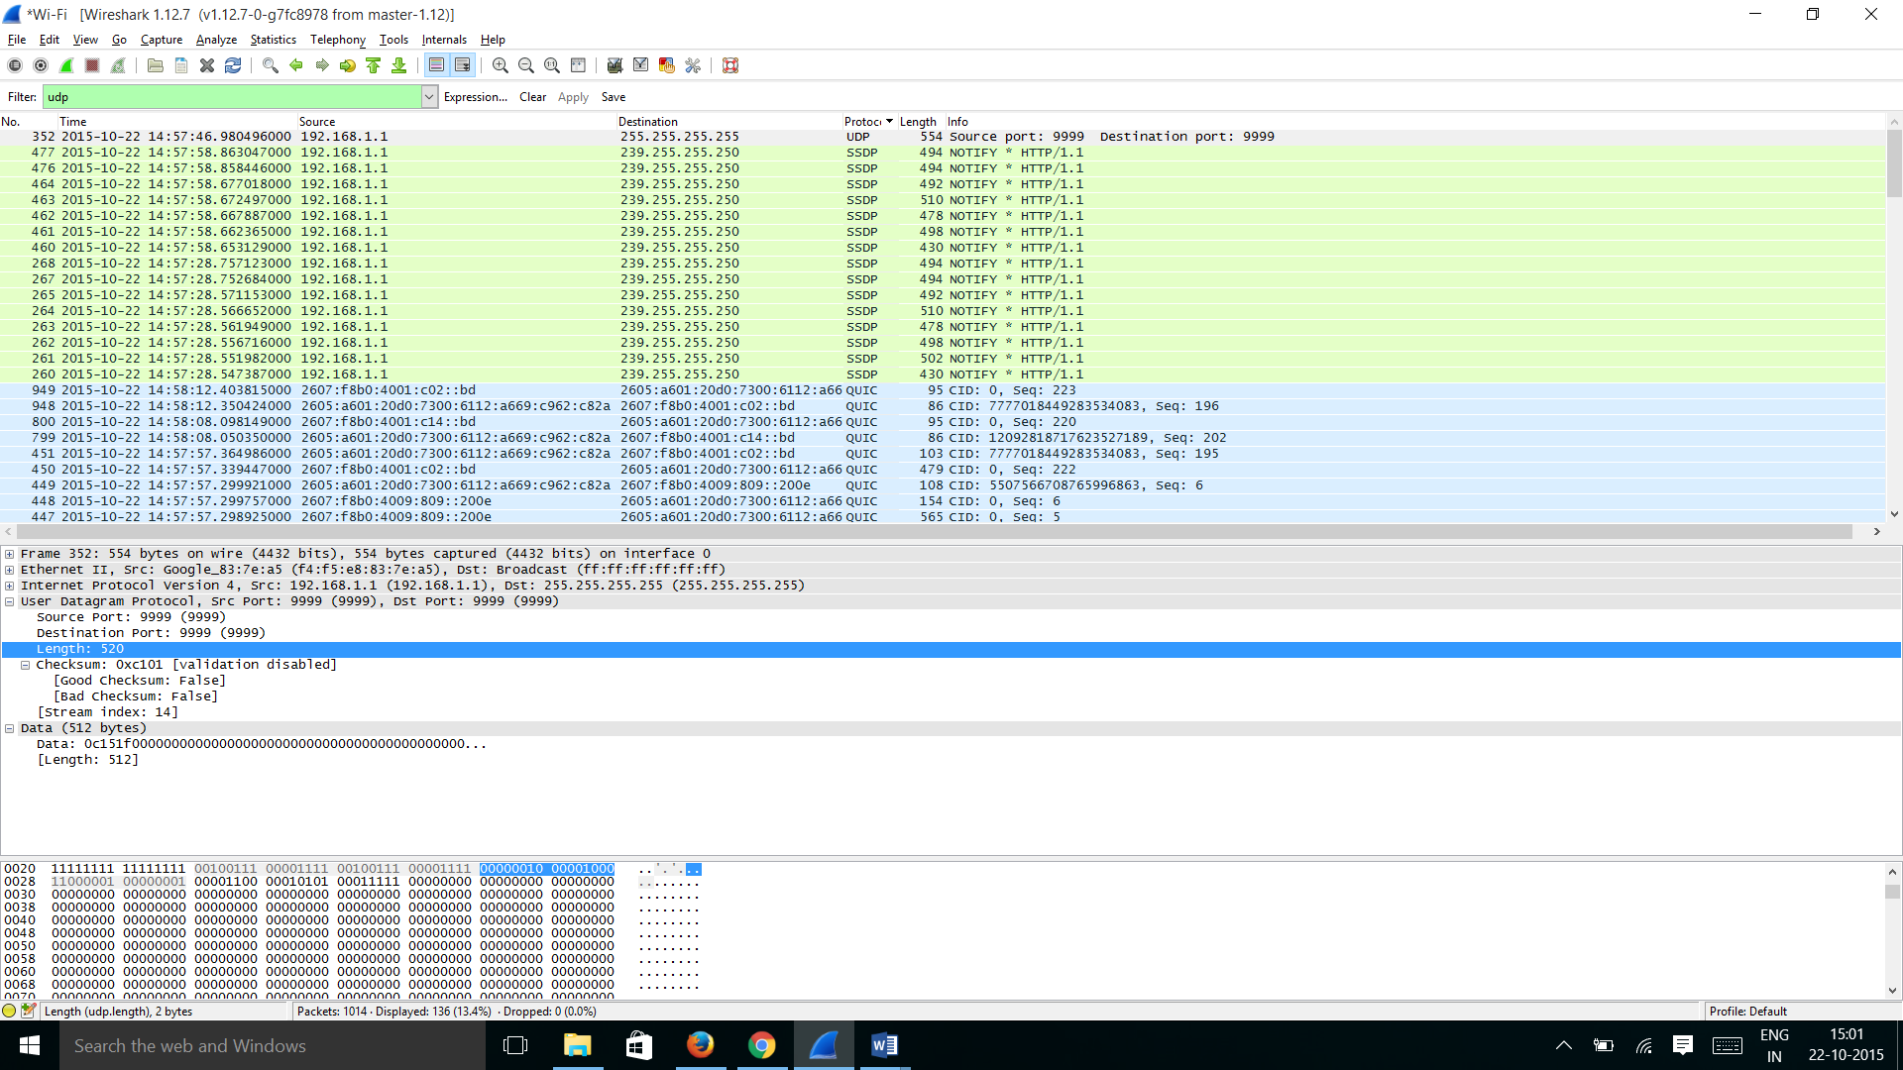

Checksum = 2 bytes

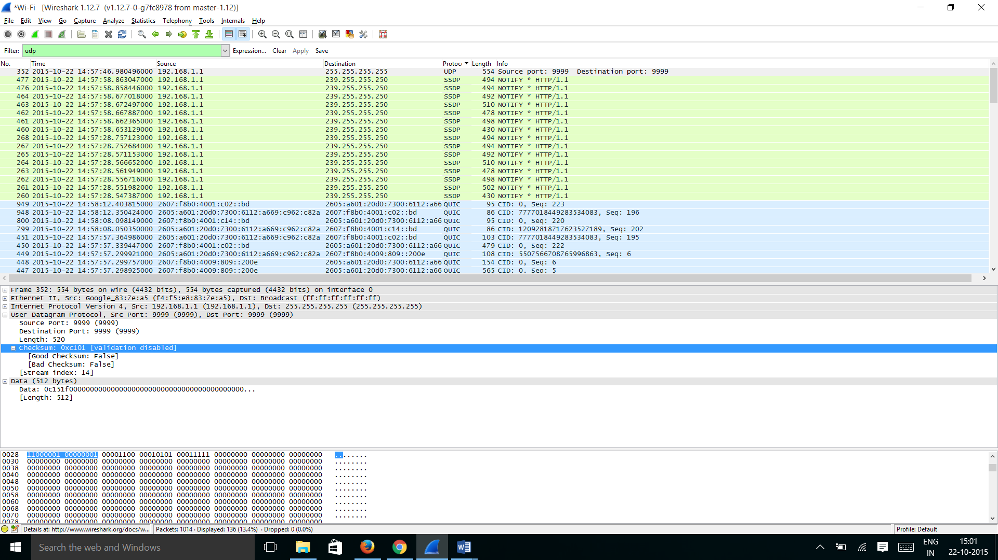

3) The value in the Length field is the length of what? (You can consult the text for this answer). Verify your claim with your captured UDP packet.

Answer:

The value in the Length field is 520 bytes, which is the sum of Data and the UDP Header Lengths.

From the Trace,

512 bytes is of Data length

8 bytes is of Header length as mentioned earlier and hence Length field in UDP Header is sum of those two which is 520 (512+8)

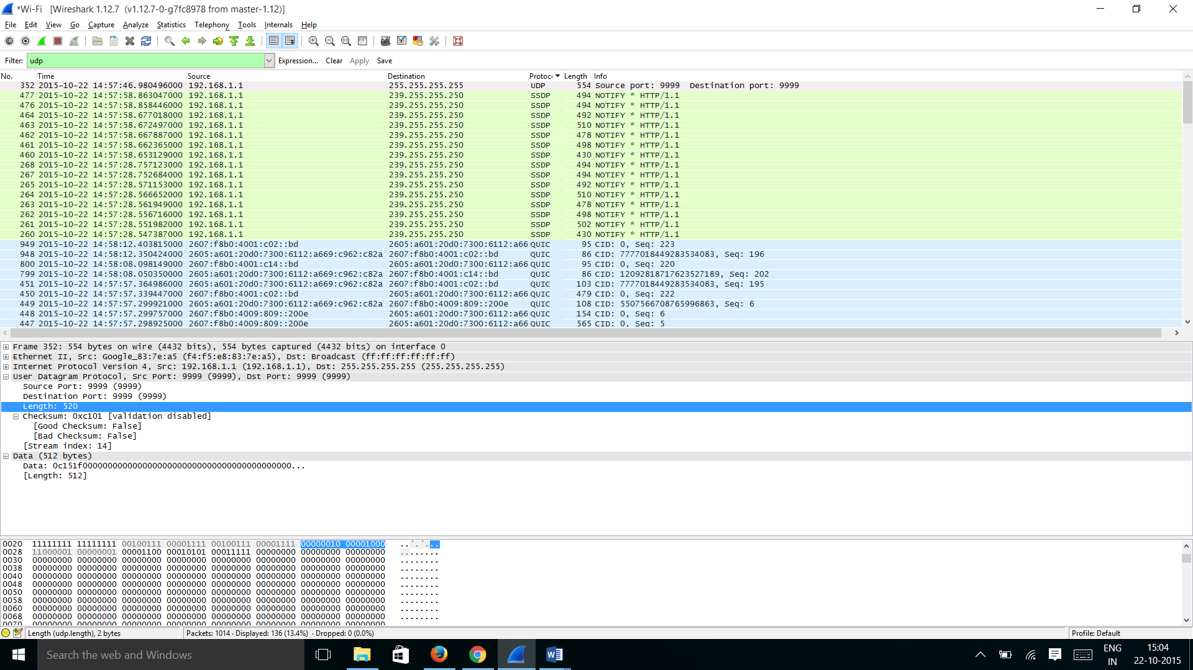

4) What is the maximum number of bytes that can be included in a UDP payload? (Hint: the answer to this question can be determined by your answer to 2. above)

Answer:

The maximum number of bytes including the Header length in a UDP payload is 65535 (2^16 - 1). The maximum number of bytes excluding the header length is 65527 {65535 – 8(header length)}

5) What is the largest possible source port number? (Hint: see the hint in 4.)

Answer:

The largest possible source port number is 65535 (2^16 -1).

6) What is the protocol number for UDP? Give your answer in both hexadecimal and decimal notations. To answer this question, you’ll need to look into the Protocol field of the IP datagram containing this UDP segment (see Figure 4.13 in the text, and the discussion of IP header fields).

Answer:

The protocol number for UDP is 17 in decimal or 00010001 in Binary form or 11 in Hexadecimal form.

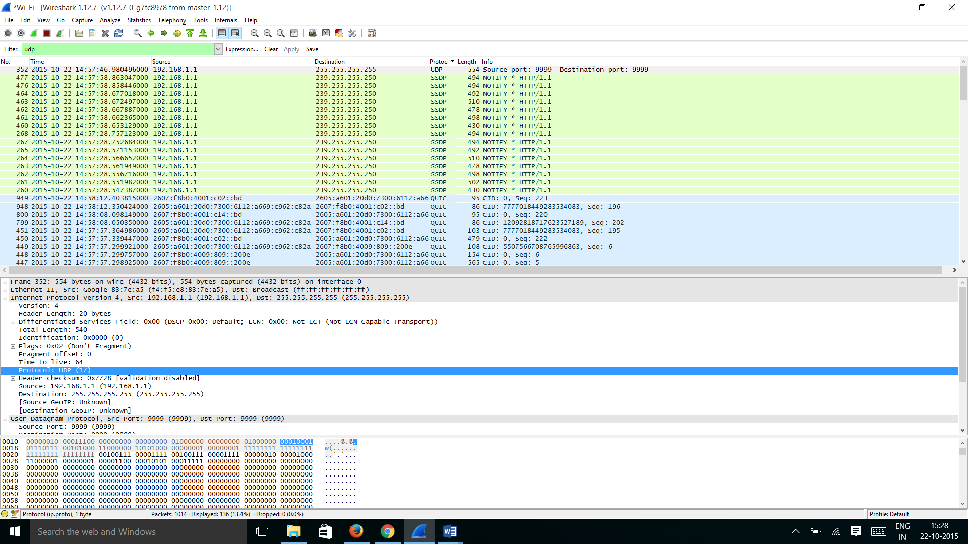

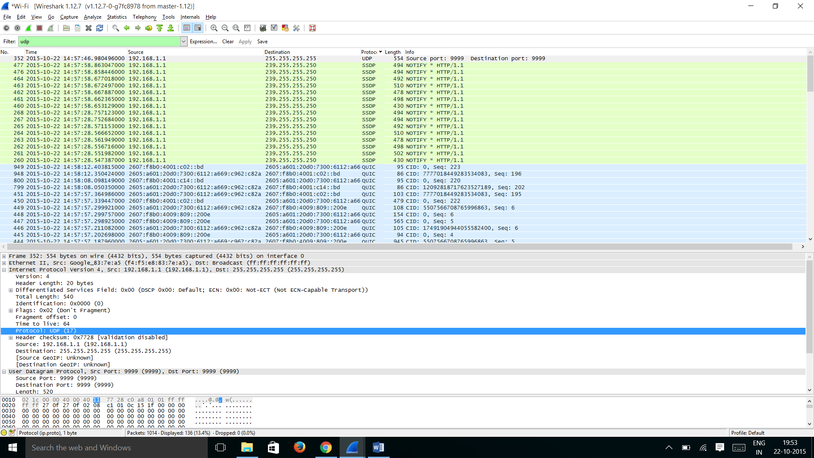

7) Examine a pair of UDP packets in which your host sends the first UDP packet and the second UDP packet is a reply to this first UDP packet. (Hint: for a second packet to be sent in response to a first packet, the sender of the first packet should be the destination of the second packet). Describe the relationship between the port numbers in the two packets.

Answer:

The Below two observations are noticed from the trace for the scenario mentioned:

1)The source port number of the UDP packet sent by the host is the same as the destination port number of the response(reply) packet [i.e., 54641 as per the trace]

2)The destination port number of the UDP packet sent by the host is the same as the source port number of the response(reply) packet [i.e., 53 as per the trace]

Request:

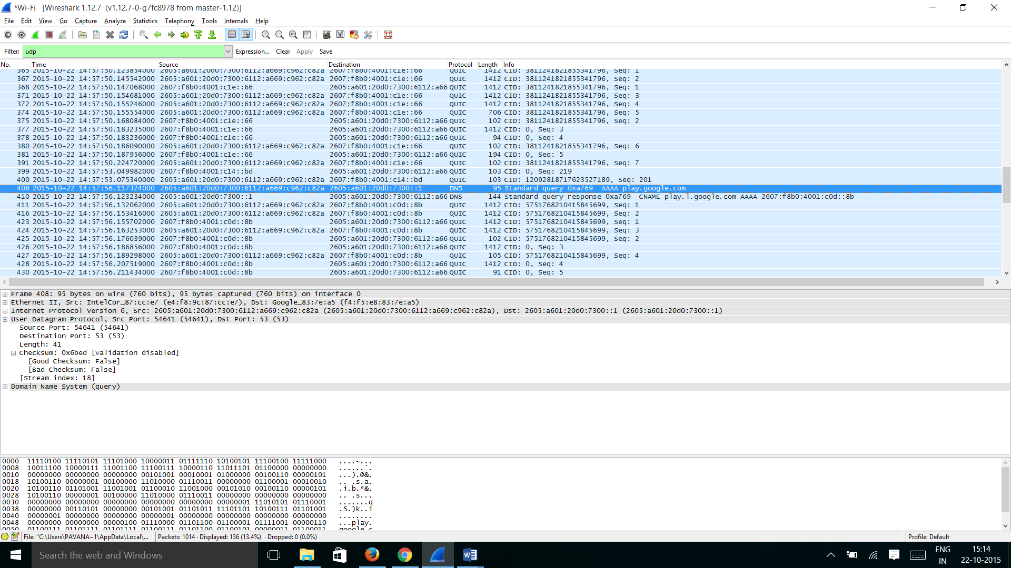Response: